https://ktar.com/story/5245900/applecare-technician-program-launches-at-mesa-community-college/

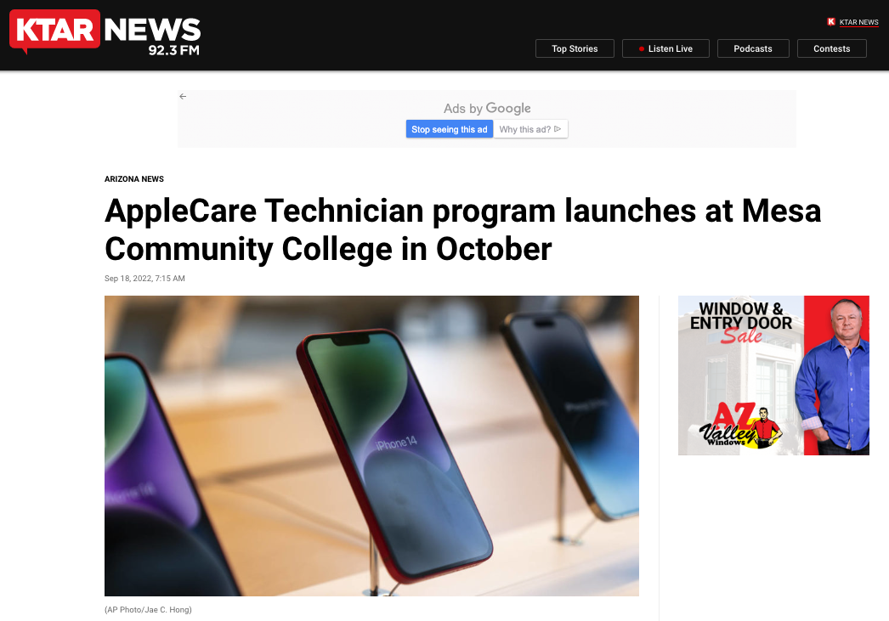

BY KTAR.COM
PHOENIX — Registration has opened for a new AppleCare Technician program set to launch at Mesa Community College next month.
The IT certification series, launched by MITI-EV, is made up of two, three-credit-hour online evening courses that prepare students to deploy, repair and support Apple products.
Students will meet in their first eight-week course (BPC260), which will run from Oct. 17- Dec. 16, online Mondays and Wednesdays.
RELATED STORIES

Mesa announces free community college tuition
“There is an immediate need for individuals with Apple ecosystem knowledge in the Valley. Schools, colleges and large-scale employers across industries rely on Apple products to conduct their business,” Diane Meza, Mesa Community College staff and Maricopa IT Institute-East Valley director, said in a press release.
“We are developing the new curriculum to include internship and apprenticeship components to provide local businesses with a talent pipeline as quickly as possible, while providing valuable first-hand experience for individuals who are newer to the IT industry.”
Registration for the spring semester course is scheduled to open Oct. 10.
“By taking the prerequisite courses students will be well on their way to gaining knowledge and skills necessary to be the first to enter the new program in spring 2023,” Meza said.
“Students enrolled during fall 2022 semester will have access to priority registration for spring courses, including BPC262.”
Tuition for each course costs $85 per credit hour plus a one-time registration fee of $15, totaling $525. Fees for materials and textbooks are not included.
The Maricopa Information Technology Institute-East Valley is made up of various local community colleges that aim to meet the demands of the emerging technological workforce.

